Workshop Facilitator:

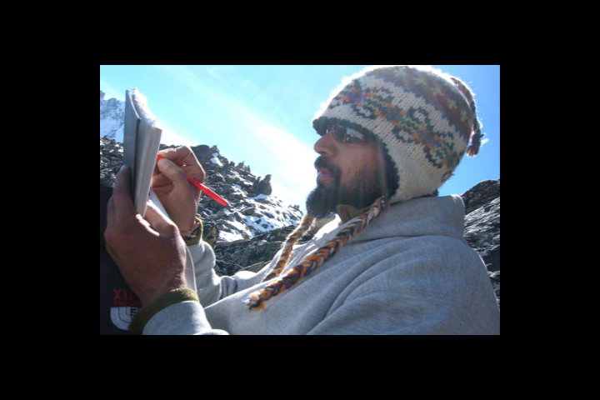

…Hawah…
(Formerly known as Rajeev R. Kasat)

Hawah, a spoken word poet also known as Everlutionary, is artist of a diverse collection of paintings and photographs. He is author of 3 books, including Trust Before Suspicion and the newly released zerONEss. He recently returned to Washington, DC after one and a half years of studying meditation and doing sustainable development work overseas. He is co-founder of the non-profit organization One Common Unity, Inc. and instructs Yoga at local area studios and classes in public high schools called Alternatives to Violence and Positive Stretch. His work can further be explored at
www.everlutionary.net

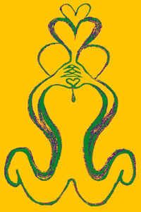

Workshop Name:

Everlutionary Change:
A Journey of Trust and Compassion

Through Meditation, Yoga, and Creative Expression

Dates, Times, and Descriptions of Workshops:

DATE: Saturday, June 24th, 2006
TIME: 3 – 6 PM
Workshop Focus: Pranayama, Meditation, Yoga Asana, and selected poetry from facilitator’s first two books.
Workshop Description:
This 3 hour workshop will begin with a series of Pranayama exercises (the science of breathing, learning how to control and use the breath to enhance creativity and health). Then we will transition into a mindfulness meditation, working on cultivating stillness, understanding impermanence, and developing compassion. The workshop will conclude with a series of yoga asanas for both the beginner and intermediate student and then spoken word poetry by the facilitator. Please come to this workshop on an empty stomach.

DATE: Sunday, June 25th, 2006

TIME: 10 AM – 1 PM
Workshop Focus: Visualization, Self-development, Forgiveness, Letting Go Of Hatred, Selected Readings, and Discussion.
Workshop Description:
After centering and reflection participants shall be guided through a forgiveness visualization, followed by original poetry and select passages from the facilitator’s first 3 books: Trust Before Suspicion, Escape Extinction, and zerONEss. There will be an incurring dialogue, as well as a questions and answers period about the causes of hatred. The last half of the workshop is meant for self-development. Selected passages will be read from M.K. Gandhi and Dr. King. Jr. This workshop shall encourage dialogue, self-reflection, sharing, and finding ways to heal pain through compassion. It will conclude with light yoga asana.

Price for One Workshop:

Pre-registration $25.00
On-site Registration $35.00

Price for Both Workshops:

Pre-registration $40.00
On-site Registration $60.00

Contact:

Hawah
161 Todd Place, NE
Washington, DC, 20002

Phone: (202)529-2125
Email: one@everlutionary.net

- Only Accepting Cash/ Check
- Meeting at the Abram’s Creek Community Bon-fire circle
- Please bring water, yoga mat, blanket, cushion, journal, and pen

